**Medical file**

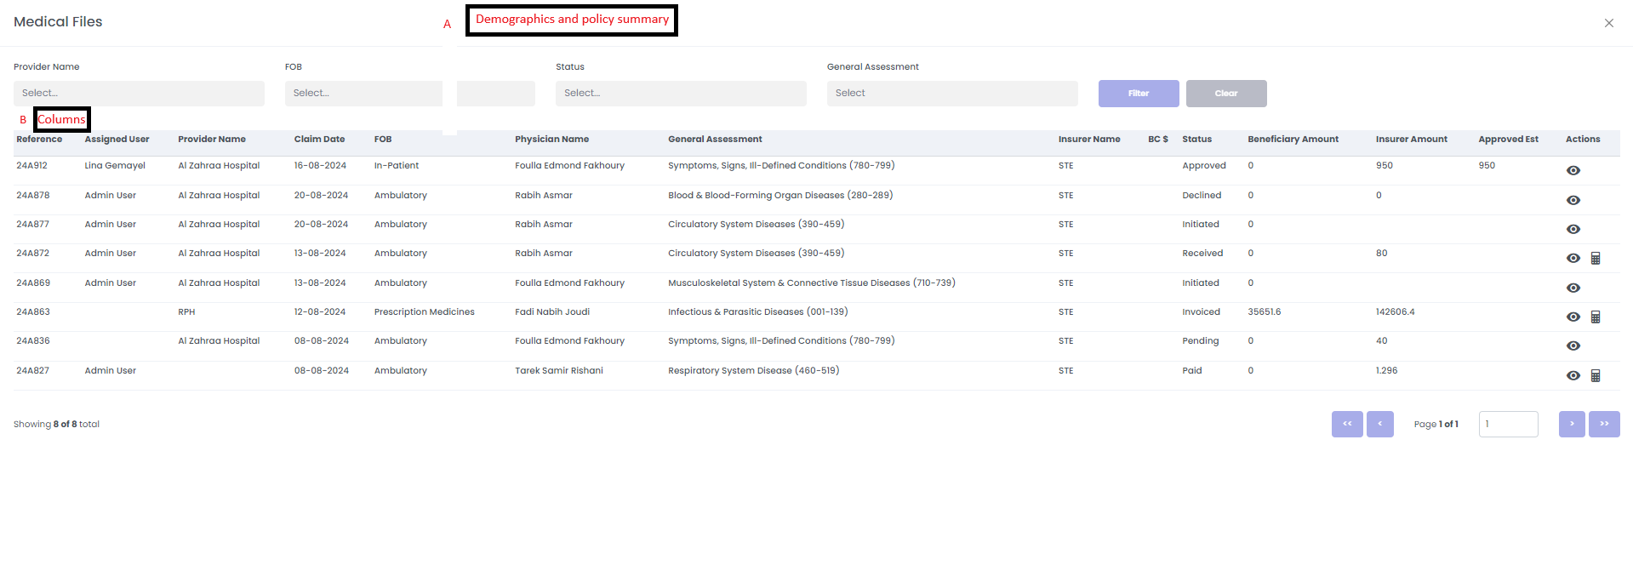

A-Demographics Included

1. Patient Name
2. DMP/Blacklist Status

B-Need to adjust the following columns:

1. Remove Assigned User and insurer name
2. To add Requested claim date/ report date, Admission claim date, discharge date
3. To Add ICD code with description
4. Replace name of Beneficiary Amount mentioned on medical file to be beneficiary copay as mentioned on claim initial page

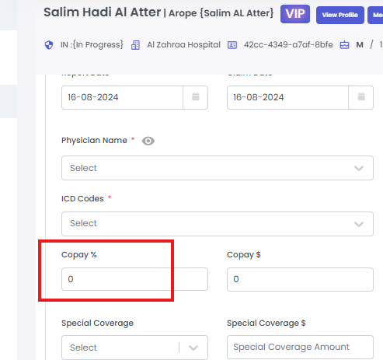 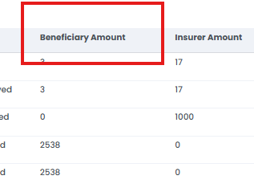

1. What is the difference between Insurer Amount and Approved Est in medical file?

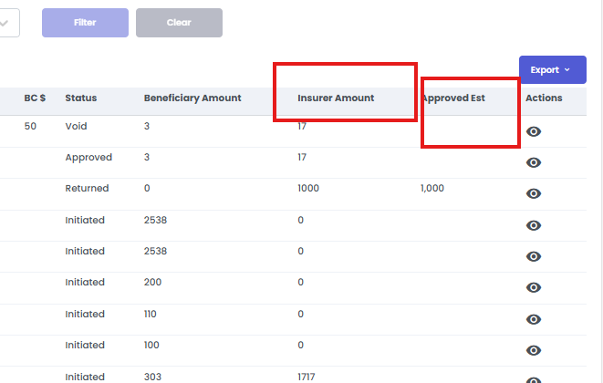

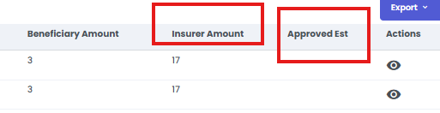

6-Estimation cost To notify the nominations between the medical file and the initial screen

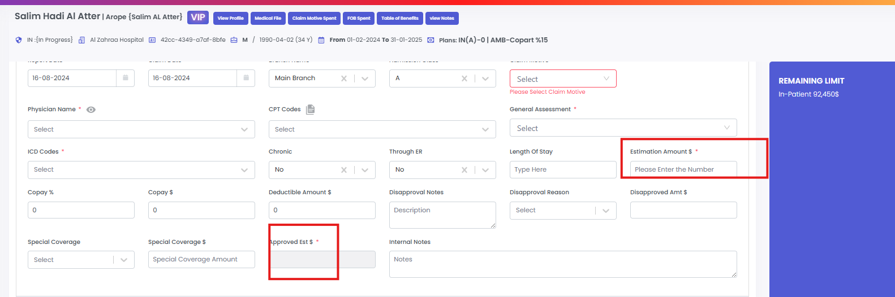

7-Add Approval Notes, Internal Notes, Medical Notes, and Processing Notes. These should be implanted in the form of a button/hyperlink that, upon being pressed, open the contents as a splash screen without taking the use to another page

8-Physician name with specialty

9-check void if its un used